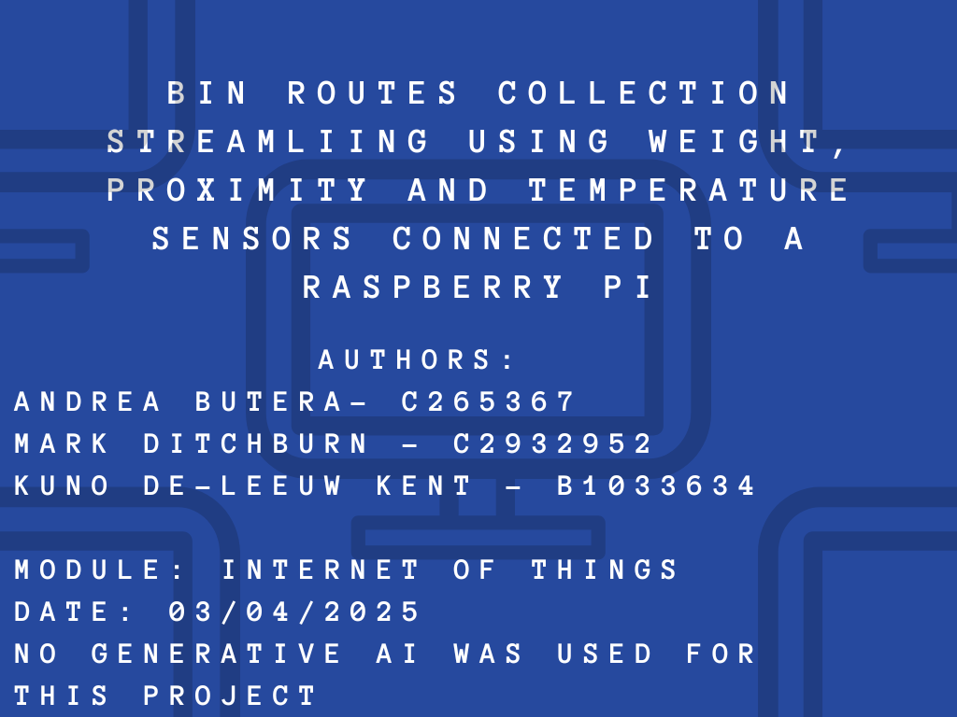

Contents

1 Introduction 2

2 Task one: Problem Identification 2

3 Task two: Proposed IoT-based Solution 2

4 Task Three: Design of the Solution 4

5 Task four: Development of the solution 5

6 Task 5: Video demonstration 8

7 Task Six: Social, Economic and Ethical issues 8

Conclusion 9

# 1 Introduction

In recent years, the integration of Internet of Things (IoT) technologies into urban infrastructure has significantly advanced the efficiency and sustainability of public services. Waste management, a critical aspect of urban living, stands to benefit greatly from these innovations. This report presents the design and implementation of a smart waste management solution developed as part of Teesside University Internet of Things project.

The proposed system leverages a Raspberry Pi in conjunction with a pressure sensor, a proximity sensor, and a temperature and humidity sensor to monitor trash bin usage in real-time. By collecting and analysing data from these sensors, the system can predict the fill levels of individual bins using Machine Learning algorithms. This predictive capability enables the creation of optimized bin collection routes based on postcodes, thereby improving collection efficiency and reducing operational costs and environmental impact.

Developed collaboratively by a team composed of Andrea Butera, Kuno De-Leeuw Kent and Mark Ditchburn, this project demonstrates the potential of combining IoT hardware with intelligent data analysis to address real-world urban challenges. The following sections detail the system architecture, hardware and software components, data analysis methods, and the results of initial testing and evaluation.

# 2 Task one: Problem Identification

Traditional waste collection systems often follow fixed schedules and routes, regardless of the actual fill levels of individual bins. This inefficiency can lead to a range of problems, including unnecessary fuel consumption, increased carbon emissions, and overflowing bins in high-usage areas. In densely populated urban environments, these challenges are compounded, resulting in higher operational costs for local councils and reduced quality of life for residents due to littering and unpleasant odours.

Furthermore, the lack of real-time data collection and predictive capabilities limits the ability of waste management authorities to adapt to dynamic conditions. Bins may be emptied prematurely when not full, wasting time and resources, or they may remain full for too long, creating health and hygiene issues.

There is a clear need for a smarter, data-driven approach to waste collection that can dynamically adjust to actual usage patterns and environmental conditions. By harnessing IoT technologies and Machine Learning, it is possible to predict bin fill times and optimise collection routes, thereby improving efficiency, reducing environmental impact, and enhancing the overall effectiveness of municipal waste management.

# 3 Task two: Proposed IoT-based Solution

To address the inefficiencies inherent in traditional waste collection systems, this project proposes a smart bin monitoring and route optimisation solution based on Internet of Things (IoT) technology and Machine Learning. The system is designed to provide real-time data collection, predictive analytics, and intelligent routing for waste collection services.

The core of the solution is built around a Raspberry Pi, which serves as the central processing unit. It is connected to three key sensors:

* Pressure Sensor: Mounted at the base of the bin, this sensor measures the weight of the waste, providing a reliable indication of how much material has accumulated.
* Proximity Sensor: Positioned near the lid, this sensor detects the distance between the top of the waste and the lid itself, offering an additional metric for estimating how full the bin is.
* Temperature and Humidity Sensor: Installed outside the bin, this sensor records ambient weather conditions. Environmental factors can influence waste decomposition rates and may also affect collection strategies.

The data gathered from these sensors is continuously monitored and analysed. Using Machine Learning algorithms, the system predicts the estimated time until each bin reaches full capacity. These predictions enable proactive alerts to be generated, notifying waste management teams when a bin is likely to require servicing soon.

Moreover, the system incorporates a smart routing feature. By analysing the predicted fill levels and total weight of bins within specific postcodes, it generates optimised collection routes. This approach prioritises areas with heavier waste loads, ensuring resources are allocated efficiently and reducing unnecessary trips.

Overall, the proposed IoT solution enhances waste collection by making it more data-driven, sustainable, and responsive to real-time conditions.

**3.1 Hardware used:**

**Ultrasonic Distance Sensor HC-SR04**: This sensor provides 2cm to 400cm of non-contact measurement functionality with a ranging accuracy that can reach up to 3mm. Each HC-SR04 module includes an ultrasonic transmitter, a receiver and a control circuit.

(<https://www.sparkfun.com/ultrasonic-distance-sensor-hc-sr04.html>)

**3.2 Interlink Electronics Force Resisting sensor**:  When the sensor is in a neutral state, the circuit remains open, and electricity is unable to pass from one wire to the other. A spacer is then affixed to this substrate to create a small separation between it and the second substrate, which is coated with a proprietary conductive ink. When force is applied to the sensor, its conductive substrate makes contact with printed circuit substrate, allowing electricity to flow from one wire to the other. The amount of electricity that is able to flow within the circuit depends on the pressure exerted on the FSR, as greater pressure brings more of the conductive material in contact with the wires and ups the electrical output in a predictable way, allowing them to detect changes in force as well.

(<https://www.interlinkelectronics.com/force-sensing-resistor>)

**3.3 DHT11 Temperature and Humidity sensor**: DHT11 module featuring a temperature and humidity sensor with a calibrated digital output suitable for use with Arduino, Raspberry Pi and other development boards.

(<https://www.mouser.com/datasheet/2/758/DHT11-Technical-Data-Sheet-Translated-Version-1143054.pdf?srsltid=AfmBOoq-38GUVw2WFBwF1AULK5iIAaBuFfqZ5X4woLUHhhVj8-Uth07q>)

**3.4 Transport Layer (Kuno):**

**3.5 Data Storage for analysis**

Effective data storage and accessibility are fundamental to the performance of any IoT solution, particularly when real-time analysis and decision-making are involved. In this project, data generated by the pressure, proximity, and temperature and humidity sensors is transmitted and stored using **HiveMQ**, a cloud-based MQTT broker designed to handle high volumes of sensor data with low latency.

HiveMQ serves as the central platform for receiving and managing the sensor data from multiple smart bins in real time. Each Raspberry Pi device is configured to publish sensor readings as MQTT messages to specific topics on the HiveMQ broker. This architecture ensures a scalable and reliable communication framework that supports multiple devices across various locations.

The stored data is then accessed by a custom-built **web application**, which retrieves the latest sensor values through MQTT subscriptions or via an integrated backend service. The application provides a user-friendly interface for monitoring current bin conditions and viewing historical data trends. Additionally, it integrates the data into a Machine Learning pipeline for predicting fill times and triggering alerts based on pre-set thresholds.

This centralised approach to data storage and analysis ensures that the system remains responsive, robust, and capable of supporting advanced features such as route optimisation and environmental analysis. By leveraging HiveMQ, the project benefits from secure, efficient, and real-time data handling, forming the backbone of the intelligent waste management system.

# 4 Task Three: Design of the Solution

The design of the IoT-based smart bin system was structured into three key phases: **data collection**, **data analysis and model creation**, and **data visualisation**. Each phase was developed with the goal of demonstrating the feasibility and effectiveness of a smart, data-driven waste management solution.

**Phase 1: Data Collection**

Due to hardware limitations, only a single Raspberry Pi was available for this project. This device was configured to function as one smart bin, collecting real-time data from connected sensors measuring waste weight (via a pressure sensor), fill level (via a proximity sensor), and environmental conditions (via a temperature and humidity sensor).

To simulate a realistic deployment across multiple bins, **mock data** was generated to represent sensor readings from additional bins located in different postcodes. This approach allowed for comprehensive system testing and demonstration without requiring a full-scale hardware rollout. The combination of live and simulated data provided a diverse dataset for subsequent analysis and modelling.

**Phase 2: Data Analysis and Model Creation**

The collected data—both real and simulated—was aggregated and processed using a custom algorithm designed to predict when bins in a given postcode would require emptying. The model analyses trends in bin fill levels, taking into account variables such as waste weight, proximity to the lid, and weather conditions, to estimate the time remaining until each bin reaches capacity.

Using this information, the system determines when the **total waste load in a specific postcode** crosses a predefined threshold, at which point it triggers a collection recommendation. This allows for smarter scheduling of bin collections and ensures that areas with higher waste accumulation are prioritised.

**Phase 3: Data Visualisation**

To enhance usability and transparency, all data is presented visually through an intuitive **web application interface**. Live graphs display key metrics such as bin fill levels, weight progression, and environmental data. These dynamic visualisations update in real time, providing users with a clear overview of system performance and current bin statuses.

In addition to monitoring, the web app also displays alerts and suggested collection routes, making it a central hub for managing and interacting with the smart bin system.

# 5 Task four: Development of the solution

**5.1 Sensing process (Led by Kuno De-Leeuw Kent)**

The sensing process is responsible for collecting real-time physical and environmental data from the smart bin using a set of dedicated sensors connected to a Raspberry Pi. These include:

Ultrasonic Sensor (HC-SR04): Measures fill level by calculating the distance to the waste inside the bin.

Load Cell via ADC (Force-Sensitive Resistor): Measures the bin’s weight and converts analog values using an exponential transformation to estimate mass.

DHT11 Sensor: Captures ambient temperature and humidity using precise GPIO timing and bit-wise data extraction.

To ensure reliable sensor integration, a custom-designed PCB Raspberry Pi shield was developed. This shield performs signal conditioning and provides clearly labelled and convenient connectors for each sensor (HC-SR04, DHT11, FSR), reducing wiring complexity and improving robustness. It also helps isolate and manage signal paths, ensuring accurate readings and easier deployment.

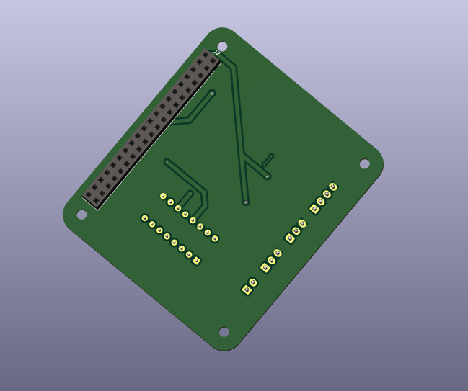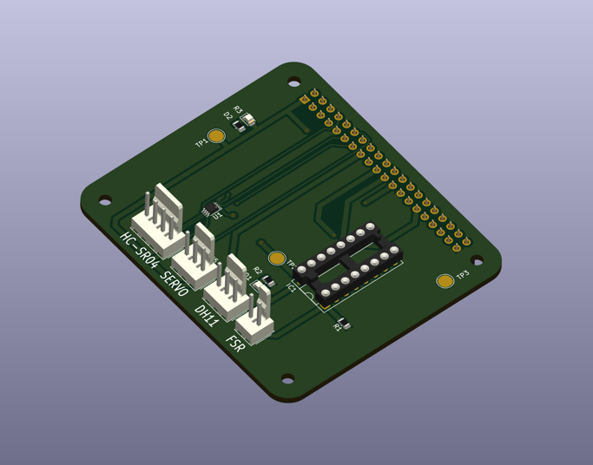

Sensor readings are structured using Python `dataclasses` (`SensorData`, `EnvironmentData`) and collected in two concurrent loops:

- `sensor_loop()`: Sends bin fill level, weight, and calculated density every 5 minutes.

- `weather_loop()`: Sends temperature and humidity every 15 minutes.

This sensing process forms the foundation of the system’s data pipeline, enabling real-time waste monitoring and environmental tracking.

Physical Build of the System:

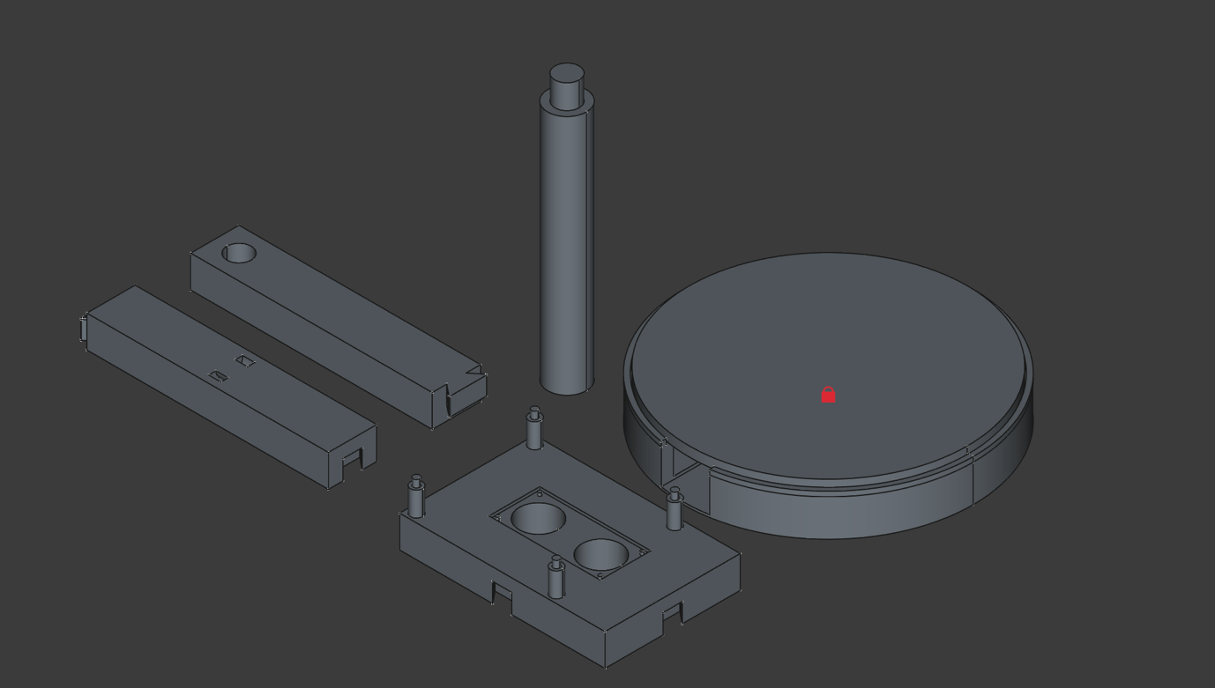

The smart bin's sensing system is housed within a custom-designed modular suports, as illustrated in the exploded CAD view above. The components are designed to be 3D-printable for ease of prototyping and replication, and they ensure secure mounting . The physical build includes the following key parts:

Main Compute Platform (bottom middle):

This serves as the foundation for mounting the Raspberry Pi, custom PCB shield and for holding the ultrasonic sensor. The Platform is designed with external dovetail mounting points to securely hold platform in place.

FSR Platform Assembly (Top Right):

This circular base provide a platform for the bin to sit on. The platform ensures even weight distribution from the bin contents above to be consintrated on the FSR. So that no matter the center of mass of the bin all the force will be registered.

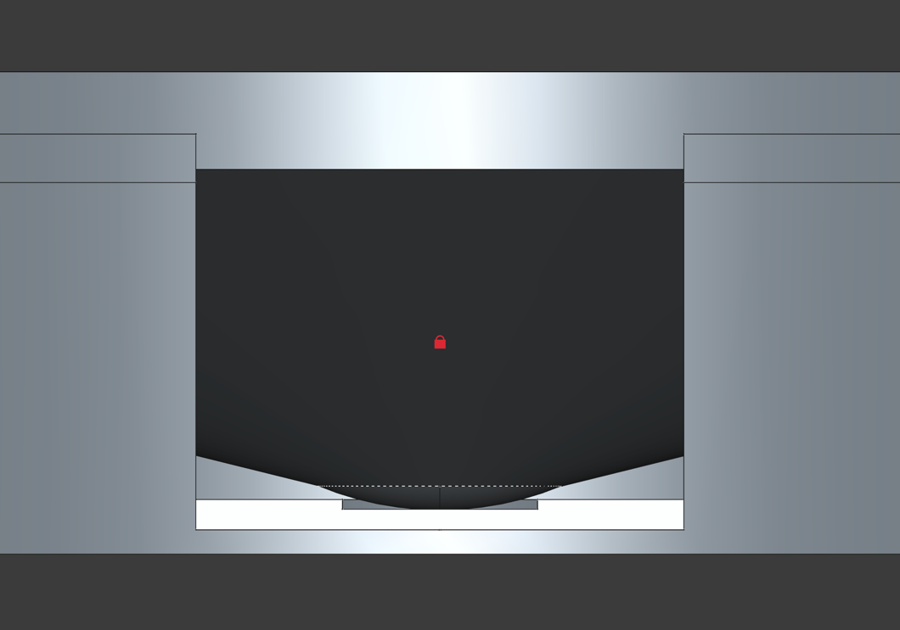

Notice in image above the top platform consintraits it’s force on the center point where FSR would mount.

Support Column (other item in photo):

Each part is designed with snap-fit joints for tool-free assembly, making the build process intuitive and modular. This physical design not only supports accurate sensor data acquisition but also ensures durability and ease of deployment.

**5.2 Transport Layer (Led by Kuno De-Leeuw Kent)**

The transport layer facilitates efficient and secure transmission of sensor data from the edge device (Raspberry Pi) to the cloud. This is achieved using the MQTT protocol, which is ideal for IoT due to its low bandwidth requirements and publish/subscribe architecture. These incude:

MQTT Client: Configured with TLS encryption and authentication credentials to connect securely to a public HiveMQ broker.

Dynamic Topic Generation: MQTT topics are generated based on bin location (`Area/Street/House`) and data type (`Sensors`, `Environment`), allowing scalable multi-bin deployment.

Real-Time Publishing: JSON payloads of sensor data are published to MQTT topics from within the concurrent loops using `client.publish(...)`.

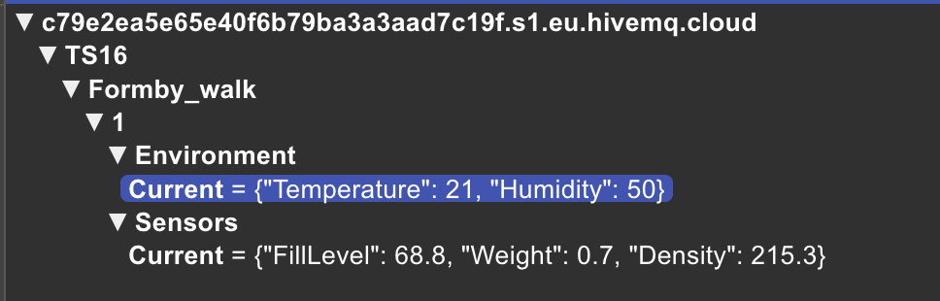

The system runs MQTT communication alongside sensor reading using Python threading, ensuring real-time data transmission without blocking execution. The transport layer enables seamless integration with cloud services for storage, monitoring, and visualization of bin conditions.

**5.3 Cloud Integration (Led by Mark Ditchburn)**

**5.4 Machine Learning Visualisation and Decision Making (Led by Andrea Butera)**

The initial script idea is to predict when bins will reach full capacity basesd on historical data. Predictions are made using linear regression to estimate the fill rate and proximity to the bin lid over time. This algorithm turned out to be too complex to incorporate to our online webpage, but we consider implementing it in future iterations.   
We have used mock data to train the model as we only had one raspberry Pi available. These are the results of the trained model before the webapp implementation:

The blue points represent the actual observed weight.

The green points represent the actual proximity values.

The black lines show the predicted values for the related measurement.

The red dotted lines represent the maximum weight and proximity allowed before sending a warning.

The actual vs predicted values of allow us to assess how well the model is performing.

Following is an example of how the model has evolved for the web app and some predictions based on both live and mock data.

# 6 Task 5: Video demonstration

A video demonstration can be find attached to the submission.

# 7 Task Six: Social, Economic and Ethical issues

**Social Issues**

The implementation of an IoT-based waste management system can lead to significant social benefits, including cleaner urban environments, reduced littering, and improved public health. However, several social concerns must also be considered:

* Privacy Concerns: Although the system does not directly collect personal data, sensors deployed in public or residential areas may raise concerns among residents about surveillance or data collection practices.
* Public Acceptance: The success of the system depends on user acceptance and cooperation, particularly in shared spaces such as residential complexes or public bins. Clear communication about the purpose and benefits of the system is essential to avoid resistance or misuse.
* Digital Divide: The reliance on advanced technologies may unintentionally exclude communities or local councils with limited access to digital infrastructure or technical expertise.

**Economic Issues**

The proposed system offers long-term economic advantages through improved efficiency and cost reduction, but also presents some challenges:

* Initial Investment: Deploying the sensors, Raspberry Pis, and supporting infrastructure involves upfront costs, which may be a barrier for smaller councils or waste management companies with limited budgets.
* Maintenance and Upkeep: IoT systems require regular maintenance, updates, and potentially replacement of hardware over time, which contributes to ongoing operational costs.
* Labour Impact: While the system may optimise waste collection, there could be concerns about job displacement or changes to the roles of waste collection workers. However, it also opens opportunities for upskilling and new tech-oriented roles.

**Ethical Issues**

In designing and deploying any technology, ethical considerations must be taken into account to ensure fair and responsible use:

* Data Handling and Transparency: Even when not collecting personal information, the handling of environmental and location-based data should adhere to principles of transparency and responsible data management.
* Bias in Machine Learning: If the predictive algorithms are trained on limited or biased datasets, they may produce inaccurate or unfair results—such as prioritising certain areas over others for bin collection. Ensuring a fair and representative dataset is crucial.
* Sustainability and E-Waste: While the system promotes sustainability through better waste management, it also relies on electronic components that may contribute to e-waste if not responsibly sourced, maintained, and recycled.

# Conclusion

This project demonstrates the potential of integrating Internet of Things (IoT) technology with Machine Learning to create a more efficient, responsive, and sustainable waste management system. By combining sensor data from a Raspberry Pi-based prototype with simulated inputs, the team successfully developed a smart bin solution capable of predicting fill times and optimising collection routes based on real-time and historical data.

The system leverages a pressure sensor, a proximity sensor, and an external temperature and humidity sensor to gather comprehensive insights into bin usage and environmental conditions. Data is transmitted and stored via HiveMQ, then accessed and analysed through a web application that provides live visualisations and intelligent alerts.

Although limited by hardware constraints, the project effectively used simulated data to demonstrate the full functionality of a multi-bin deployment. The resulting predictive model and web interface showcase a practical and scalable approach to tackling inefficiencies in traditional waste collection methods.

Overall, the project highlights the power of IoT and data-driven decision making in addressing everyday urban challenges. With further development and deployment, the system has the potential to reduce operational costs, minimise environmental impact, and improve the quality of public sanitation services.